**Lab – 25**

**Student Name: Navneet P**

**Student ID: AF0411619**

***Topic-Working with Pandas Dataframes***

Functions used in the assignment:

1. **Pandas.DataFrame** – A 2-dimensional, size-mutable, and labeled data structure in Pandas, similar to an Excel spreadsheet or SQL table.
2. **to_string()** – A method to convert a DataFrame into a string format for easy display or output, with options for formatting.
3. **read_csv()** – A Pandas function to read a CSV file into a DataFrame, allowing for efficient data manipulation.
4. **head()** – A method that returns the first 5 rows of a DataFrame (or a specified number of rows).
5. **tail()** – A method that returns the last 5 rows of a DataFrame (or a specified number of rows).
6. **loc[]** – A method to access rows and columns in a DataFrame by labels (index) or a boolean array.
7. **to_csv()** – A method to export a DataFrame to a CSV file, allowing data to be saved in a readable format.

Q1. Create sample DataFrame using pandas with example.

Solution:

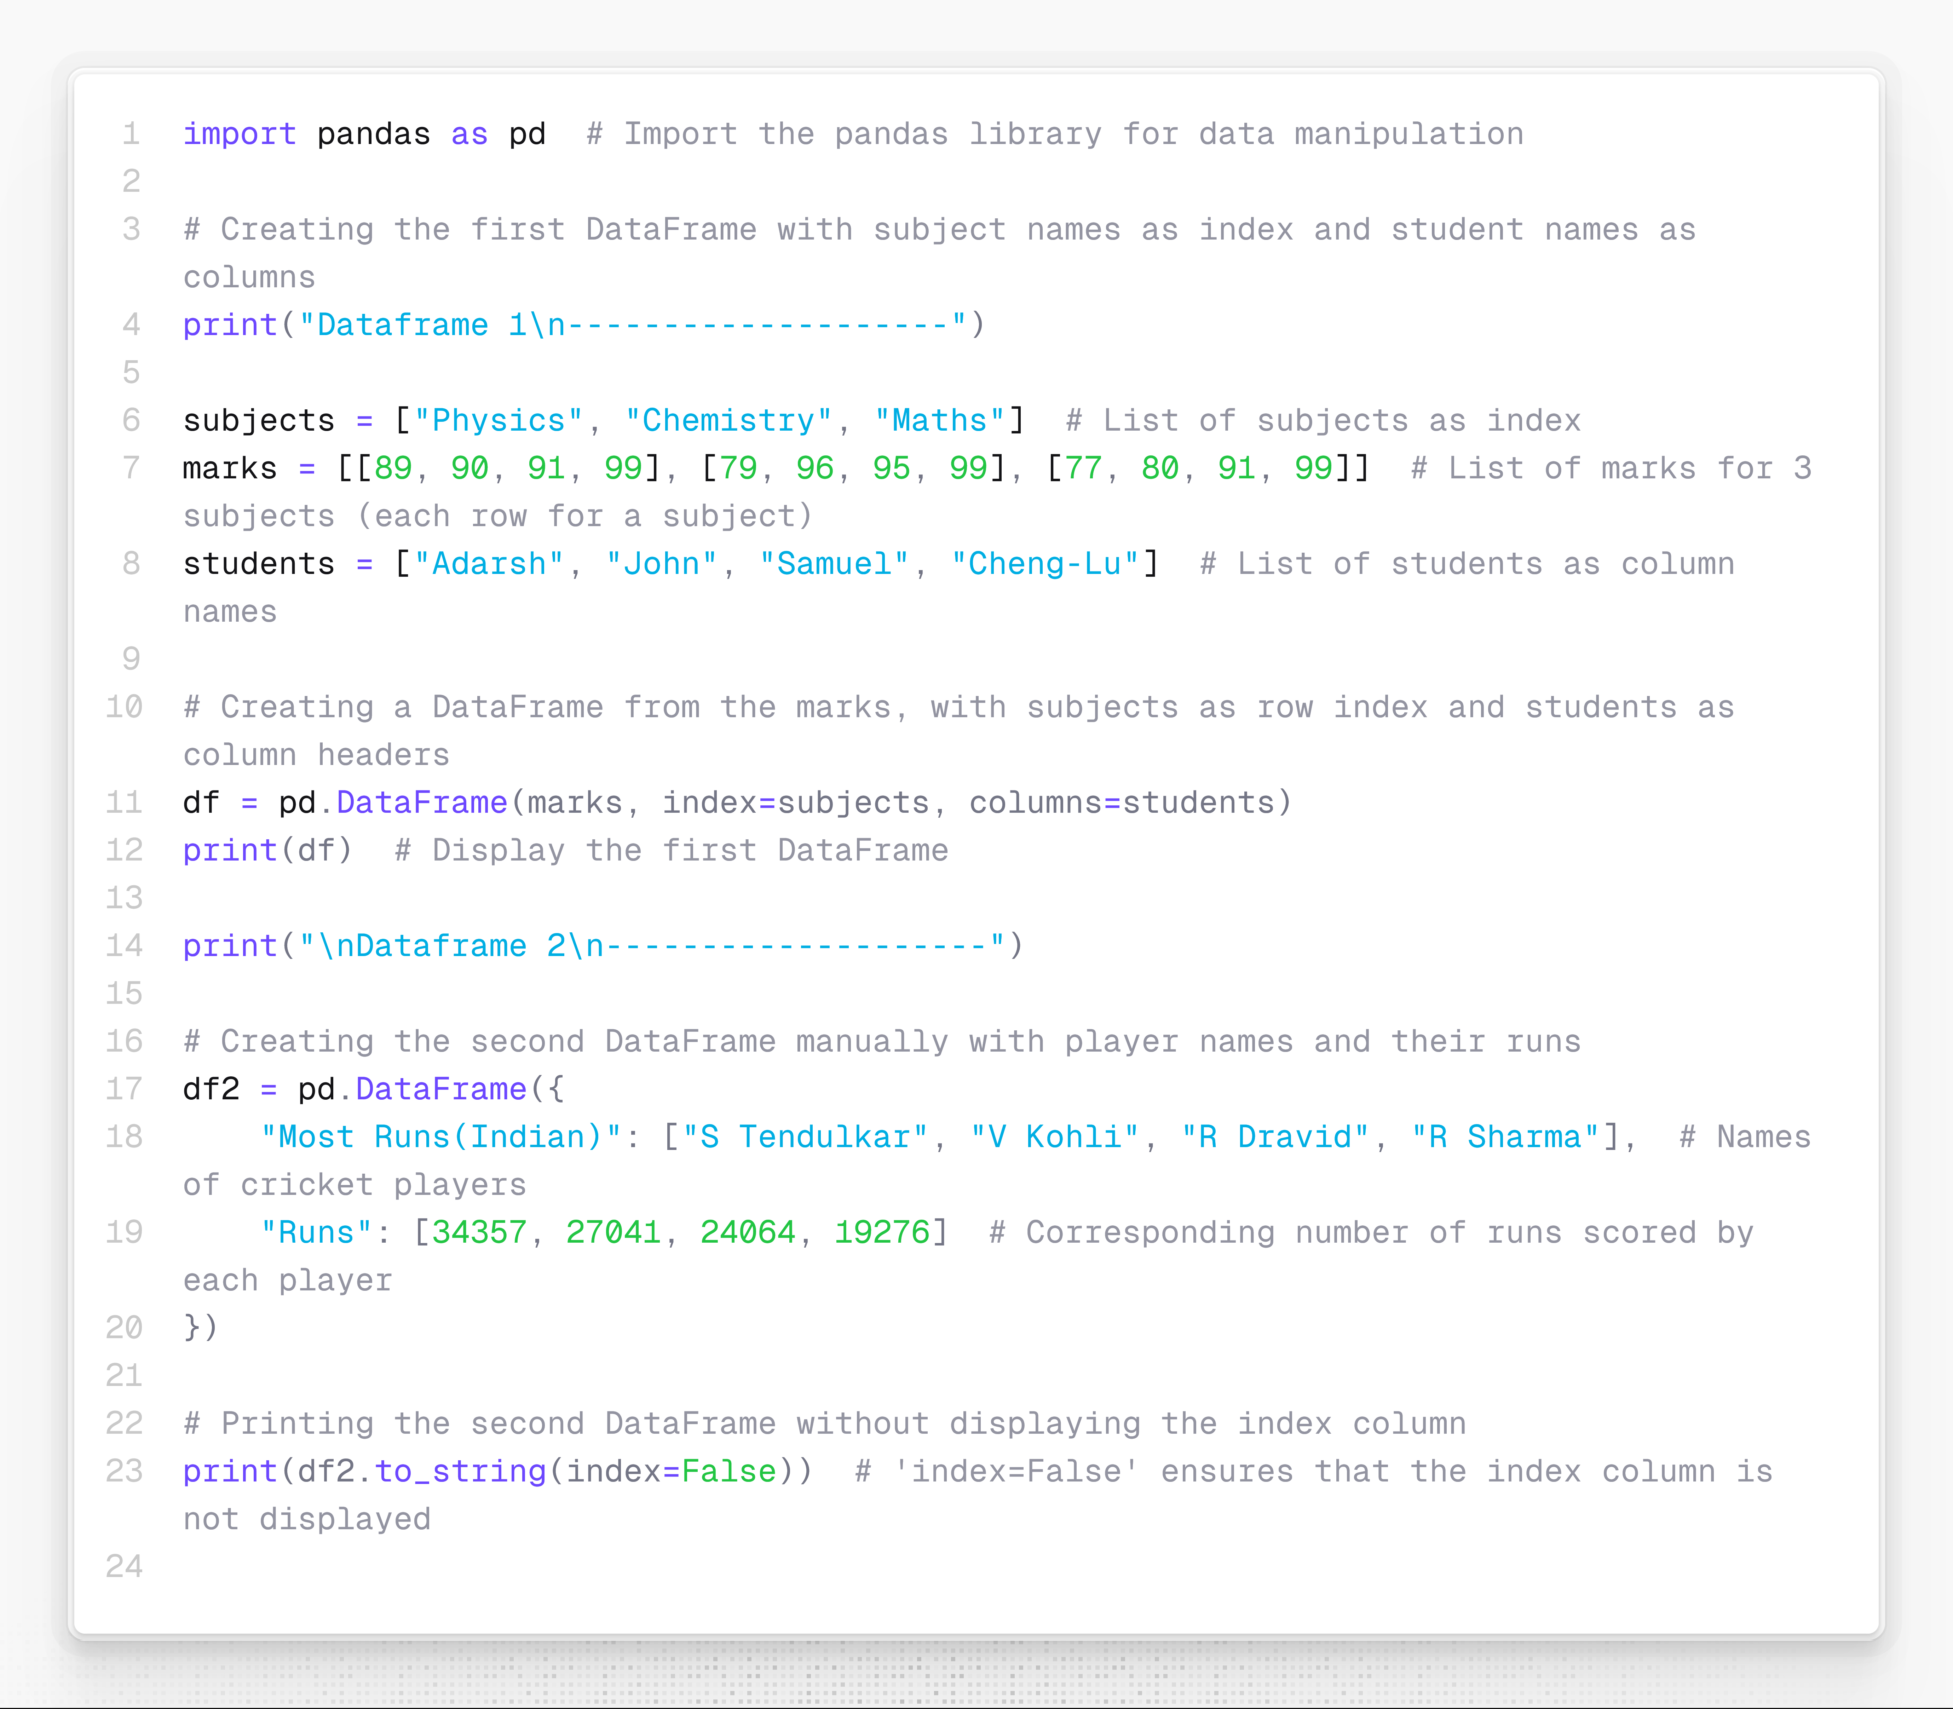

Output:

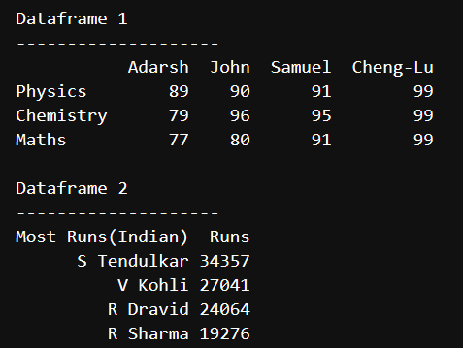

Q2. Read 8362_data.csv print complete data and display columns[ student name,attendance,mcq,lab]

Solution:

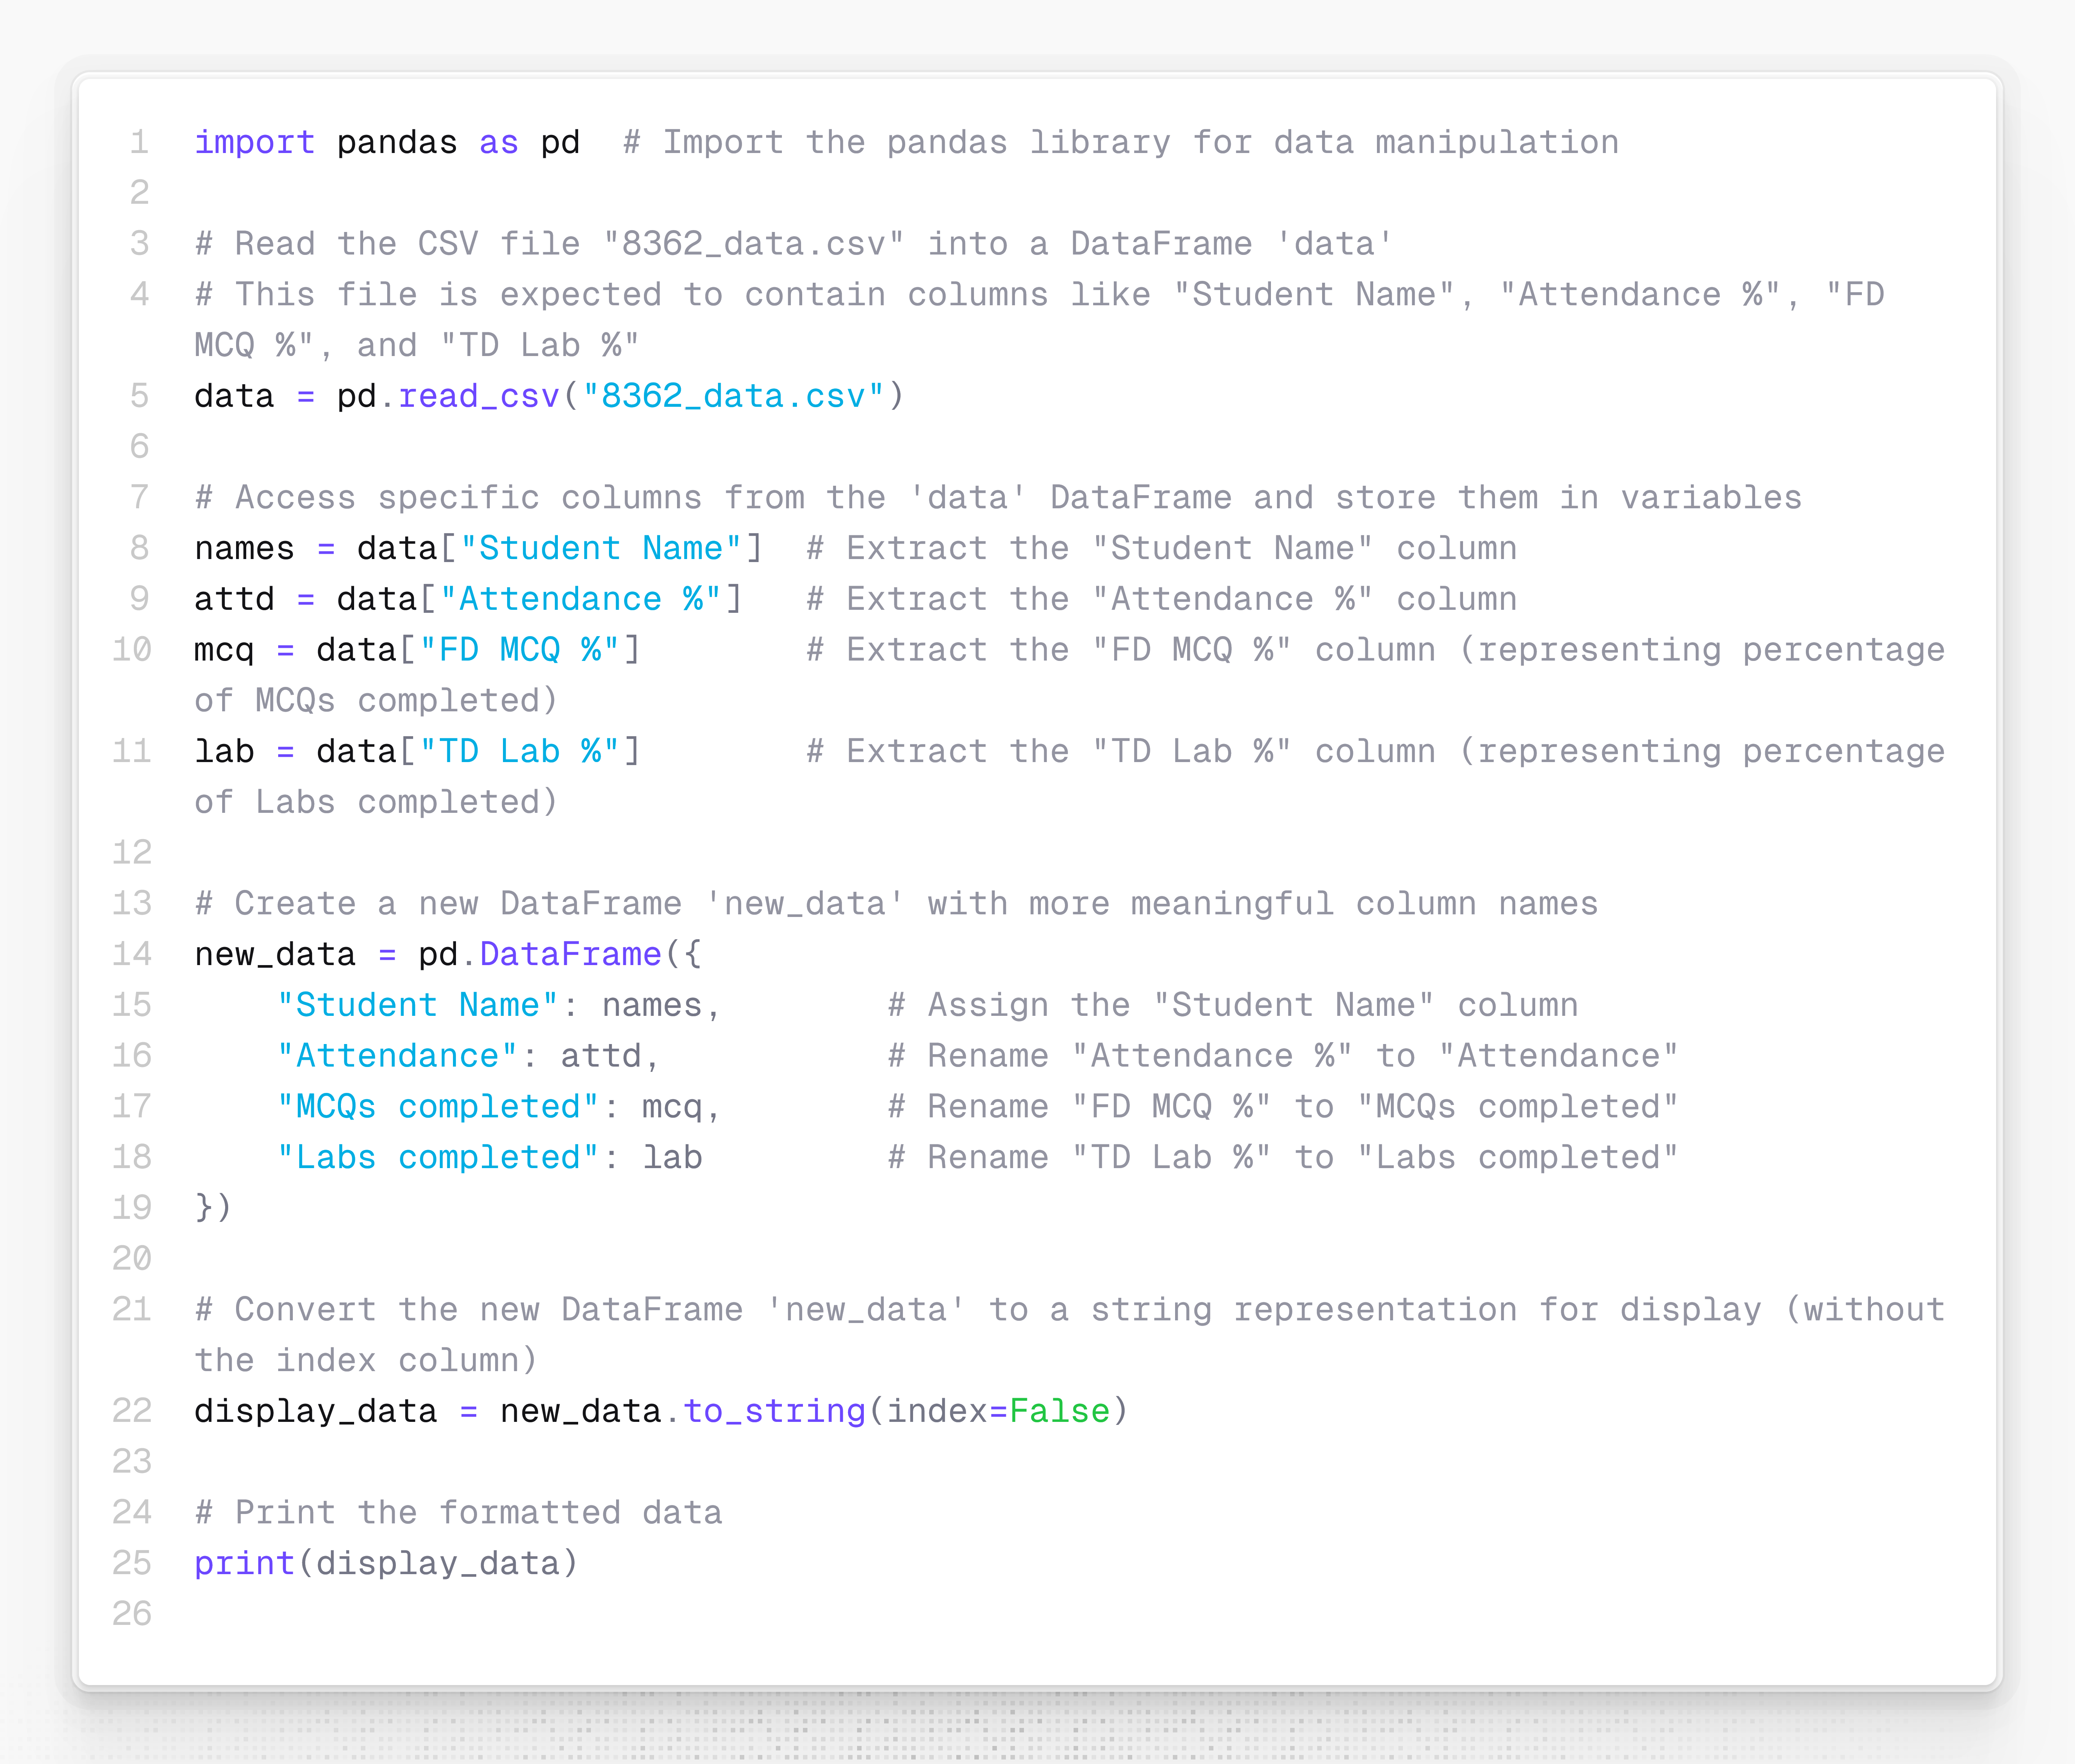

Output:

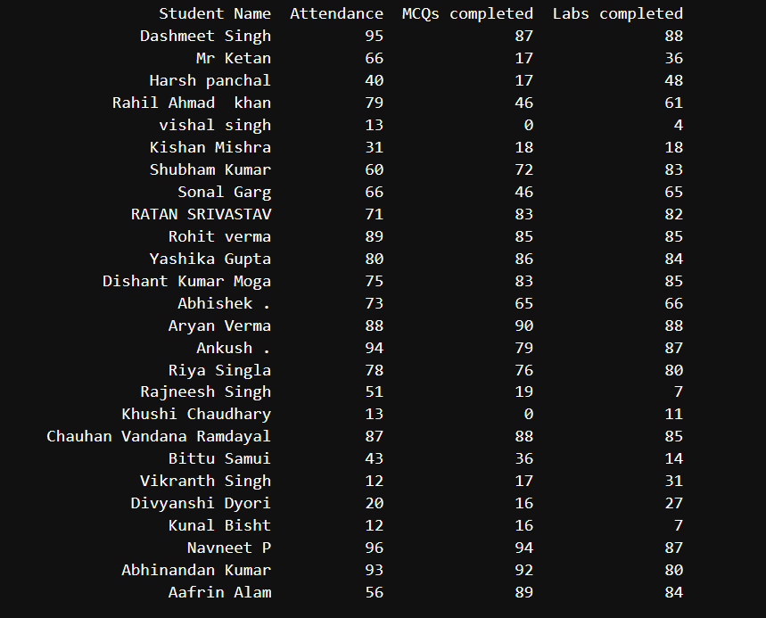

Q3. Display data using head() Function,tail() Function and Slicing data[4:21]

Solution:

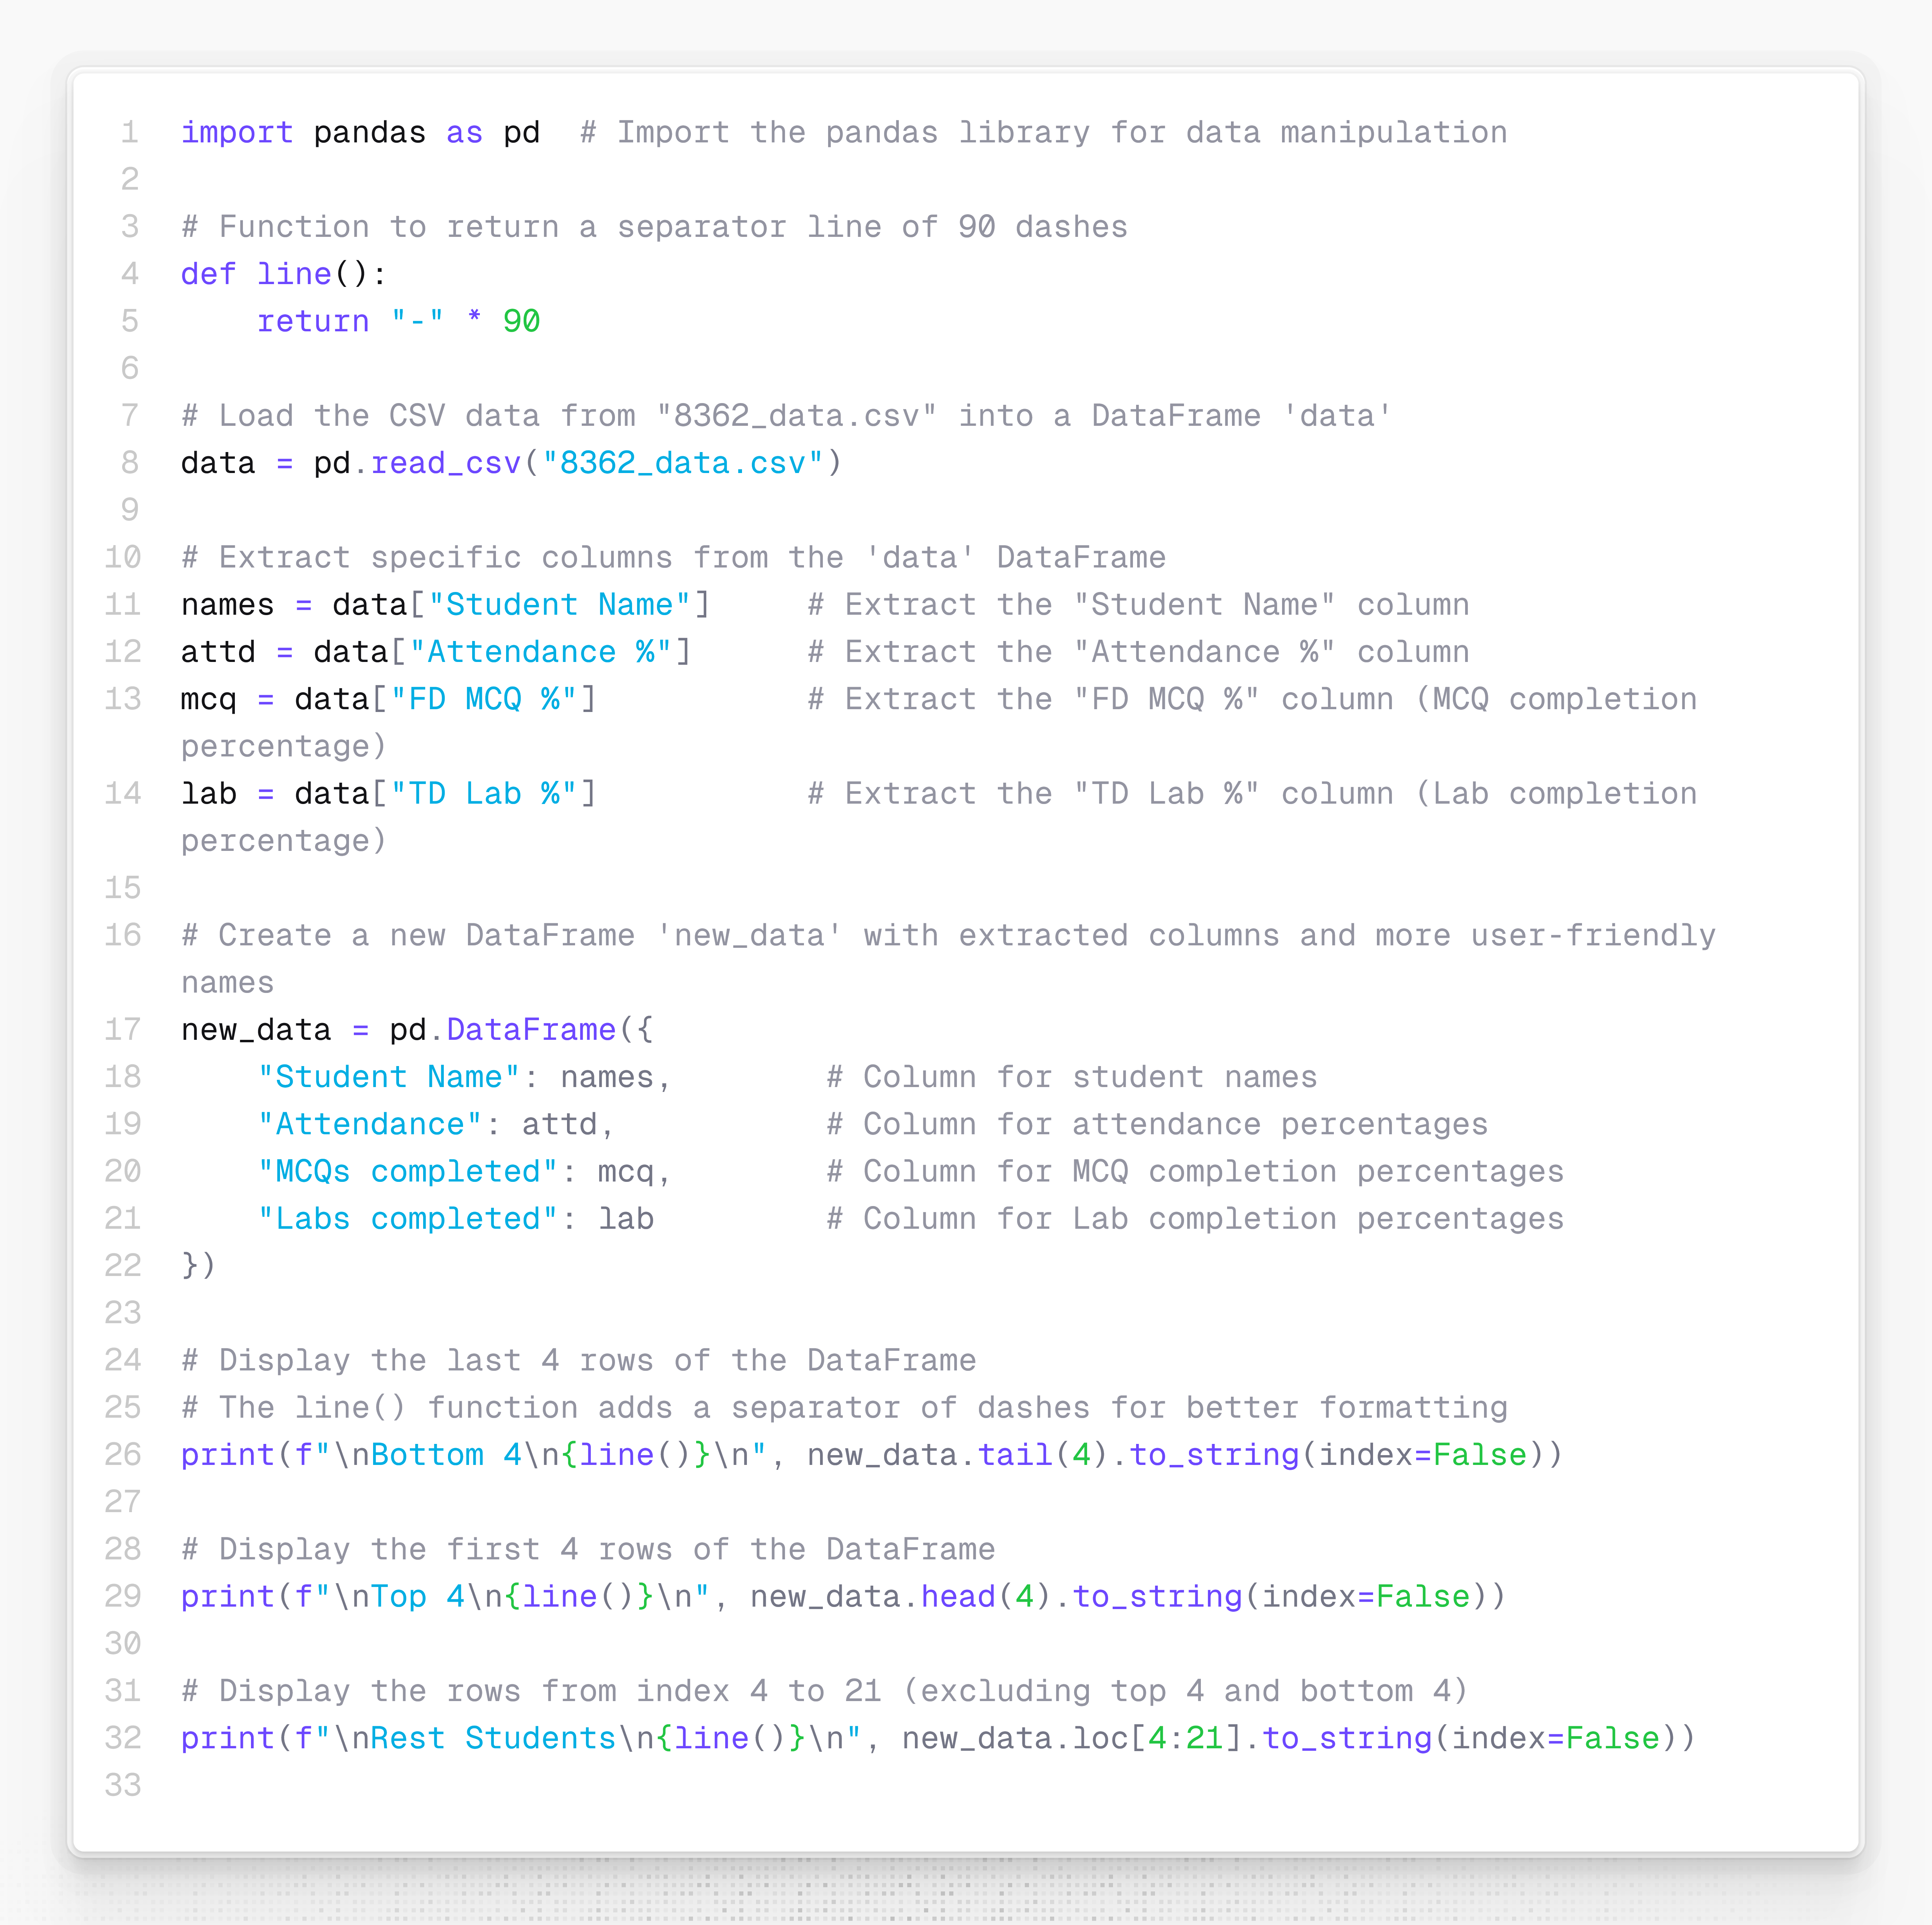

Output:

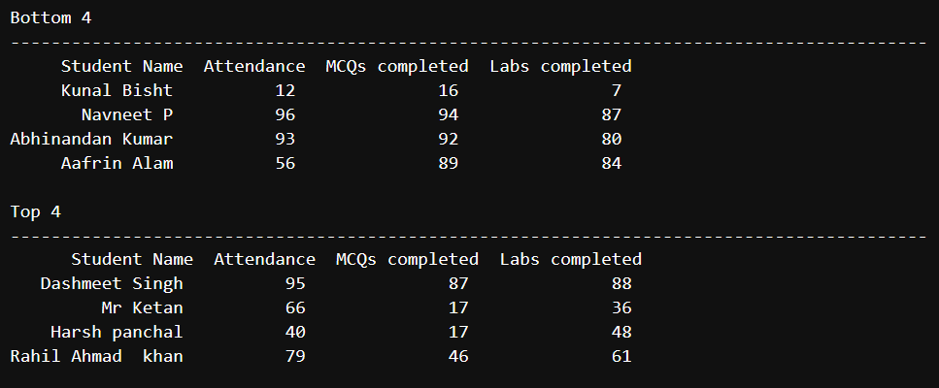

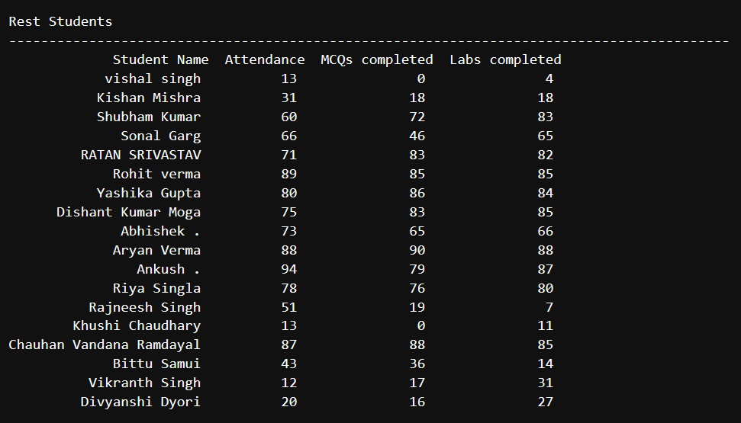

Q4.Export data set using .to_csv() only selected columns[ student name,attendance,mcq,lab]

Solution:

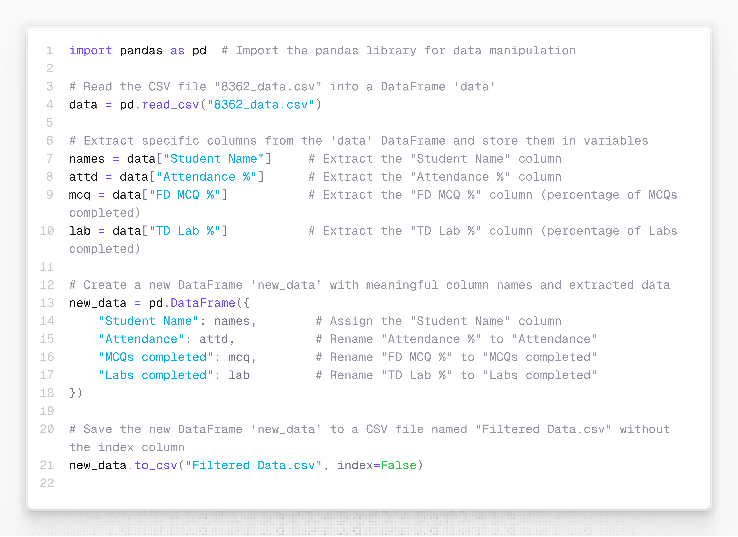

Output:

